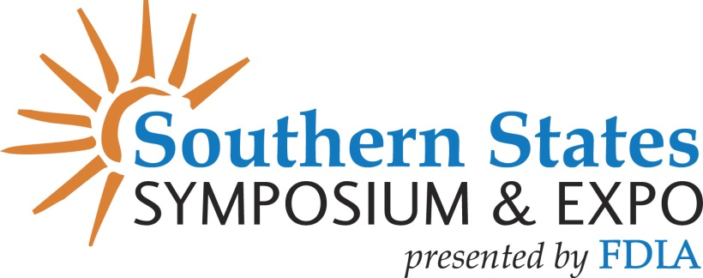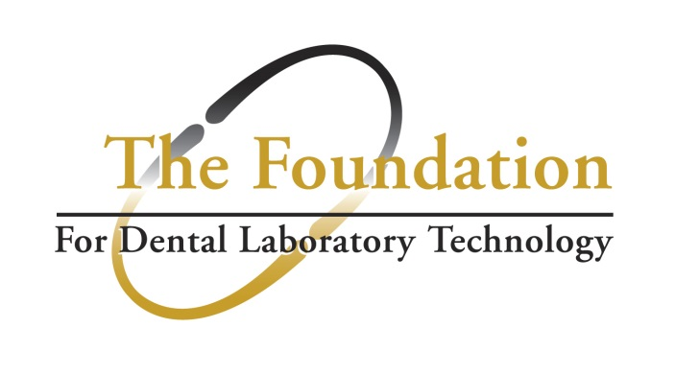

BOARD MEMBERS - WE NEED YOUR SUPPORT & PARTICIPATION!

At the 2024 Southern States Symposium & Expo, FDLA will join together again with the FDLT to increase awareness of the opportunities for enhancing education in the industry. We ask that you assist with these efforts in the following ways for the Symposium:

MONETARY DONATIONS TO PURCHASE WINE / LIQUOR:
- Donations will be used to purchase wine and / or liquor for FDLA to be used in the wine toss in the Expo Hall

□ $50 □ $100 □ Other $___________

DONATE BOTTLES OF WINE / LIQUOR FOR THE WINE TOSS:
- Donate bottles of wine and / or liquor to FDLA for the wine toss! Most of us all have bottles at home that could be donated for the cause. (Please circle wine or liquor below).

□ 10 Bottles of Wine/Liquor □ 15 Bottles of Wine/Liquor □ Other ___________

Complete this form and return to FDLA by May 15. Join us in Building the Future of Dental Technology!

DONOR INFORMATION:
First Name ______________________________________Last Name______________________________________
Organization___________________________________________________________________________________
Phone_____________________________ Email______________________________________________________

EMAIL: Email donation form along with payment information to: lauren@executiveoffice.org
FAX: Fax donation form along with payment information to: 850.222.3019
MAIL: 2024 Southern States Symposium & Expo (FDLA) / 325 John Knox Road, Suite L103, Tallahassee, FL 32303

PAYMENT:
□ Check (made payable to FDLA) Check # Check Amount $ ___________________________
Credit Card □ Master Card □ Visa □ Amex Charge Amount $ __________________________
Card #___________________________ Exp. Date: Security Code:
Signature of Card Holder: Print Name:
Billing Address:

