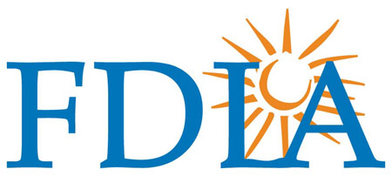

West Florida Workshop – Saturday, December 9, 2023
Leixir Dental Group (3659 Tampa Road, Oldsmar, FL 34677)

Aesthetic Characterization of 3D Printed, Immediate Full-Arch Provisional Restorations
Presented by Aleksandra Polczynski
Sponsored by GC America Inc.
Course Description: This comprehensive course is designed for dental technicians looking to enhance their skills in the art of characterizing full-arch provisional restorations using light-cured stains. Aesthetic excellence is crucial in modern dentistry, and the ability to create natural and lifelike restorations is in high demand. This course will discuss how immediate full-arch rehabilitation has been revolutionized by digital workflows. Through a combination of lectures, hands-on demonstrations, and practical exercises, participants will learn to master the techniques required to achieve beautiful, patient-ready provisional restorations. Participants do not need to bring any materials.
Course Objectives:
- Understand digital and conventional workflows for fabricating full-arch provisional restorations.
- High-level understanding of designing full-arch provisional restorations using Exocad-based CAD software.
- Identify the best staining techniques for various materials commonly used in provisional restorations.
- Understand how to adapt characterization to the specific requirements of each case.
- Discuss the importance of communication with the dental team to meet patient expectations.

- Identify common challenges and errors in fabricating and characterizing full-arch provisional restorations.
Schedule of Events:
8:00 a.m. – 5:00 p.m. Hands-on Workshop (lunch included with registration)


CDT/RG: 8 Hours of Scientific Credit • State of Florida: 8 Hours of General Credit
Capacity 15. Participants must pre-register by 11/29/2023.

Registration Form – Workshop
Saturday, December 9, 2023 • 8:00 a.m. – 5:00 p.m. (Lunch Included)
Leixir Dental Group (3659 Tampa Road, Oldsmar, FL 34677)

FDLA Member pre-registration for Workshop $299.00 pp = $
To receive the member rate, each registrant must hold a valid FDLA membership.

Non-member pre-registration for Workshop $349.00 pp = $

Total for Meeting Registration Enclosed = $

Name CDT? Yes No CDT #:
Laboratory FL Dental Laboratory License #:
Address
City/State/Zip Code
Email Phone

Payment Information:

___Enclosed is my check to “FDLA” ___ Charge to my credit card ___ Visa __ MC __ AmexCard No. Security Code: Exp. Date
Name on Card Signature
All refunds must be received in writing by FDLA by November 29, 2023. No refunds will be given after November 29, 2023. Email with credit card information to cwelty@executiveoffice.org or mail to 325 John Knox Road, L103, Tallahassee, FL 32303.
For details, call Christina at 850-224-0711 or email cwelty@executiveoffice.org.

